Stage One: Discovery
The first stage of sermon preparation is discovery. The product of discovery is the message. The message is what God wants to say through this text, to these people, at this time. It ought to be stated in a simple theme statement.

1. Identify your text.
A biblical sermon derives its message from the Bible. Choosing a primary text is the simplest and strongest way to present God's Word. Multiple text messages put a greater burden on the preacher to make the correct connections and to construct things effectively. A preaching text ought to represent a complete unit of thought in context, not a sentence fragment. The text ought to offer one big idea. The larger a text you choose, the less depth you will be able to deliver.
Workshop Example: Romans 8:18-25
Top of Form 1
Your Sermon Text: 
Bottom of Form 1

2. What's the Big Idea?
Every text has a big idea - the one main idea that God wants to communicate through this text to these people at this time. In other words, the big idea is the message. Try to express your big idea in a single, simple sentence. Aim for less than 10 words if you can. Try not to omit anything important, yet without using any conjunctions (i.e. and, but, if, or). Complex theme sentences tend to create complex sermons.
Workshop Example: "We won't groan forever."
Top of Form 2
Your Big Idea:
First Concern
integrating text and heart
The preacher's first task is to engage the listener. Preachers should not assume that the listener comes to church with a deep desire to hear the preacher's sermon. People have short attention spans. It is most likely more effective for the preacher to imagine the listener sitting with his hand's folded saying, "so what, prove to me that what you're going to say is worth the investment of my time."
Perhaps the best way for the preacher to help the listener with this question is to ask the question, "What's the story?" Every text has a story. The Bible is populated with real human beings going through most all the things that our listeners experience. Working with the humanity in the text will give the listeners something that they can identify with. Perhaps they will find that the Bible is relevant after all.
Finding the heart in the text is much more engaging than being cute or clever.
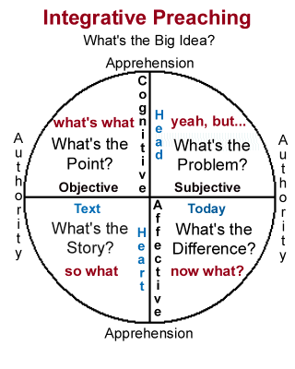
Bottom of Form 2

story.html3. What's the Story?
Every text has a story. If we can identify the humanity inherent in the text we have a stronger chance of communicating powerfully with our listeners. The most effective way of addressing the classic homiletic problem of text and today is to develop the human elements of the passage.
Workshop (Rom.8): These were tough times to be a Christian. Christians were falling out of step with Roman society. It would only get worse under Nero. The promise of the gospel didnÌt seem to match up with the believerÌs experience. There was a lot of groaning going on.
Your Sermon "Story":
Top of Form 3
Bottom of Form 3

point.html
point.html4. What's the Point?

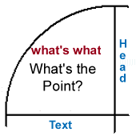
Having understood the story, now we look to make the point. In many (most) cases, the point of the sermon will be summarized by the "big idea" or message that was determined earlier. The point is the propositional (cognitive) truth intended by the text.
Workshop (Rom.8): There is a better future coming which will cause our present sufferings to fade. God is at work, fulfilling his plan. Instead of feeling anxious, the believer eagerly anticipates the final state when groaning will become irrelevant and glory will be revealed.
Your Sermon "Point":
Top of Form 4
Bottom of Form 4

problem.html
problem.html5. What's the Problem?

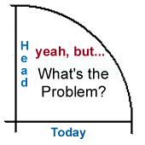
Having established the point, the preacher/exegete ought to consider the problem. There is always a problem. If listeners have no objection or contrary assumptions, then there is little point in preaching. Dealing with the problem helps us access a deeper level in the listener's mind.
Workshop (Rom.8): Patience is not our strong point. We want everything now because we donÌt trust the future. We like things where we can see them, under our control. Can we trust God enough to keep going for the time being? Do we believe he will deliver on his promise?
Your Sermon "Problem":
Top of Form 5
Bottom of Form 5

difference.html

difference.html6. What's the Difference?

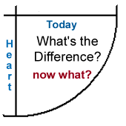
We preach to encourage change. The sermon always intends a difference. Discovering the message requires exegesis not only of the text but also of the listeners. The challenge is to find the emotional keys that will motivate the desired change in the heart and life of the listener
Workshop (Rom.8): If we can trust God then we can take the hits. If we can really believe, deep inside, that God loves us and that he will deliver, then we donÌt have to be afraid of anything the world has to throw at us. We would be free, then, to pursue our callings with a holy abandon.
Your Sermon "Difference":
Top of Form 6
Bottom of Form 6

Stage Two: Construction
The second stage in homiletic process is construction. The thing we are building is a sermon, that is to say, a structure that is sufficient to communicate the message.

7. Find an Image
There is tremendous power in a well chosen image. A story, metaphor, illustration, or word picture can give the preacher tremendous power.
Workshop Example: "groaning"
Top of Form 7
Your Sermon Image:
Bottom of Form 7

8. "So What?"
The listener needs a reason to listen. We can't assume that they will be appropriately motivated to listen avidly to what we say. Imagine the listener sitting back in his or her chair saying "so what." In this opening section of the sermon the preacher connects the original story behind the text with the contemporary listener's situation to answer the listener's desire for relevance. The most effective way to achieve this is to Tell the Story. You can never go wrong with a story.
Workshop (Rom.8): Open with the Charlie Brown "AAARRRGGGHHH" - deep down, full study.html
study.htmlbody groan. Describe how we're all groaning about something due to the fact that we were created for heaven and we have to live here on earth. Connect with the Roman Christians who knew what it was to groan. Their attempts to integrate into Roman society wasn't working and it was only going to get worse. We can relate to that.

Your Sermon "So What":
Top of Form 8
Bottom of Form 8

9. "What's What?"
Having established a connection between the listener and the text the preacher now works to Make the Point. Telling the story is important but just as important is the preacher's effort to establish the propositional truth intended by the text. The preacher needs to lay out the cognitive content of the sermon so as to inform the listener of "what's what."
Workshop (Rom.8): Establish the proposition that our current experience of suffering is limited in scope. Paul uses accounting language to show how our present sufferings do not add up relative to the glory that will be ultimately revealed in us. Show how God is working on a plan that is not always readily apparant to us. It puts our groaning into perspective. Illustrate this with the way my children whine (groan) about silly things when they can't see with the perspective that I am able to recognize. Describe how hope comes when we gain the biblical perspective and trust God to deliver on his promises.
Your Sermon "What's What":
Top of Form 9
Bottom of Form 9

10. "Yeah, But..."
Now the sermon moves to the listener's side. Just because we have made the point does not mean that the listener is prepared to respond to the truth. There is always something getting in the way - some objection or presupposition that interferes with our ability to obey. "Imagine the listener saying, "Yeah, I understand what the Bible says, but I have this problem..."The wise preacher will take advantage of the situation in order to engage the listener at a deeper level. Such a preacher will Engage the Problem.
Workshop (Rom.8): The problem with this text is that the promise is all in the future. Heaven is a long way off when you are tired. The preacher describes his or her own fatigue reflecting on a time (at the Dentist's office) when the pain went on too long. Enough already! Theologians talk about "the already" and the "not yet." But this requires patience. Identify with the listener's frustration while raising the issue of trust. It comes down to how much we believe God?
Your Sermon "Yeah, But... ":
Top of Form 10
Bottom of Form 10

11. "Now What?"
The sermon concludes with the question, "now what." Having established the point and engaged the problem, the preacher moves to Imagine the Difference. The intent is to motivate the listener to a meaningful obedience through affective appeal and tangible example.
Workshop (Rom.8): Offer the biblical analogy of the groaning experienced in childbirth. Relate directly to my own experience when our children were born. Admit that it really does hurt. The suffering is real, but then so is the hope. Encourage the listener to hold on and maintain hope because it will be worth it in the end.
Your Sermon "Now What":
Top of Form 11
Bottom of Form 11

12. Settle the Title (Taglines, Theme)
The title ought to create interest in the sermon. Preachers may want to offer a creative title making use of the "big idea" statement as a subtitle.
Workshop (Rom.8): "Groaning for Glory: We won't groan forever."
Top of Form 12
Your Sermon Title:
At this point it might also be helpful to revise the big idea statement.
Your Revised Big Idea:
It is also helpful to identify taglines for each of the four quadrants of the sermon. Taglines give the sermon definition, helping both the preacher and the listener to track with the presentation.
#1 - Tell the Story
Workshop (Rom.8): We're all groaning about something.
Your First Tagline:
#2 - Make the Point
Workshop (Rom.8): We won't groan forever.
Your Second Tagline:
#3 - Engage the Problem
Workshop (Rom.8): I'm tired of groaning.
Your Third Tagline:
#4 - Imagine the Difference
Workshop (Rom.8): Our groaning will be worth it.
Your Fourth Tagline:
Bottom of Form 12

Stage Three: Assimilation
The third major stage of the homiletic process is assimilation. The goal is to access the unction of the Holy Spirit. The preacher strives to be filled with the message by the Spirit of God.

groaning.htm
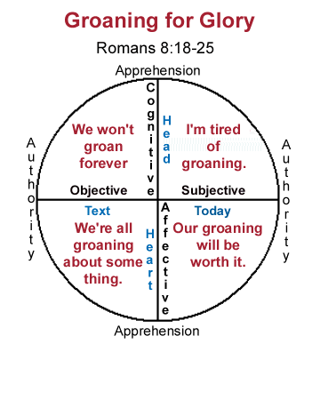
groaning.htm13. Pray It

Prayer is the primary instrument by which the sermon gains power. The entire homiletic process needs to be bathed in prayer. At this stage, however, the preacher makes prayer a special emphasis, dedicating time and energy to the spiritual disciplines in preparation for the event of the sermon.

14. Speak It
Here the preacher puts words to the sermon. As preaching is an oral process, the sermon is best prepared by working it out verbally. The challenge is not so much to memorize the sermon but to get comfortable with the concepts so that the sermon can be preached confidently and effectively in the oral medium.

15. Live It
A third aspect of assimilation is the deliberate and intentional attempt to live out the implications of the sermon. If the preacher cannot identify where he or she has actually lived the sermon, he or she is probably not ready to preach.

Stage Four: Delivery
The final stage in the homiletic process is the delivery of the sermon. This is that unique, unpublishable event when people actually hear from God.

Manuscript
At this stage, the preacher gathers the notes that will be used. The preacher chooses between a full manuscript which affords greater confidence but less audience connection, an oral manuscript (preaching without notes) which allows for greater connection but less confidence, or a partial manuscript somewhere in between. The best approach allows for the best integration of both confidence and connection.

Physical Presence
The physical presentation of the preacher ought to be helpful. Gestures, vocal quality, and attire can either enhance or detract from the message. Preachers should not overemphasize such things, but pay enough attention to insure that everything is working toward a powerful physical package.

Attitude
It is not uncommon for a preacher to experience fear (or pride) prior to or during the preaching event. We might not be able to avoid fear entirely, but we can channel it. There is a difference between the fear of man, which debilitates us, and the fear of God, which motivates us. The effective preacher knows the difference and channels his attitude appropriately.

Top of Form 13

Bottom of Form 13
index.htmlindex.htmlBacktoTopBacktoTop
search/search.htmlsearch/search.html

